_____ANSWERS____

PSYCHOLOGY ATAR
Task One
Topic Test
Biological Influences and
Bases of Behaviour

Time: 45 minutes Score: /46

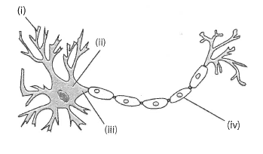
The diagram below shows the structure of a motor neuron.

Structure of a motor neuron

- Describe the purpose of the structure labelled at (i) in the diagram. (1 mark)

To take impulses/messages away from CNS to muscles
- Identify the division of the nervous system in which a motor neuron would be found. (1 mark)

Peripheral NS OR Somatic NS

- Name TWO neurotransmitters that are secreted in the brain. (2 marks)
Any 2 of dopamine, serotonin, noradrenaline, acetylcholine, endorphins

- Briefly describe how neurotransmitters are transferred from one neuron to another. You may use an annotated diagram to answer this question. (4 marks)
Neurotransmitter released from vesicle in axon ending (1)
Diffuses across the synapse (1)
Attaches to specific receptors on postsynaptic membrane/dendrite membrane (1)
Causes action potential to occur on membrane (1)
Fully annotated diagram correct = 4 marks

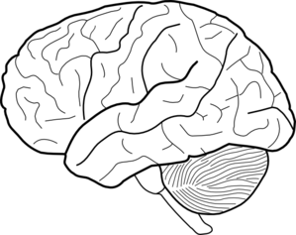
A
B

Referring to the diagram above, name parts A and B, and briefly explain how they work together to enable a person to respond to a bicycle bell being sounded while they are walking in the middle of a pathway. (5 marks)

Part A = Temporal lobe (1)
Part B = Cerebellum (1)

Any 3 marks but must mention role of temporal lobe and cerebellum at least once for each
The sound of the bell would be transmitted/processed by temporal lobe (1)
Comprehension of the sound occurs in Wernicke’s area (1)
Person responds by moving out of the way/turning their head (1)
Cerebellum assists in the maintenance of balance/movement in one direction/refined motor coordination (1)

___________________________________________________________________________

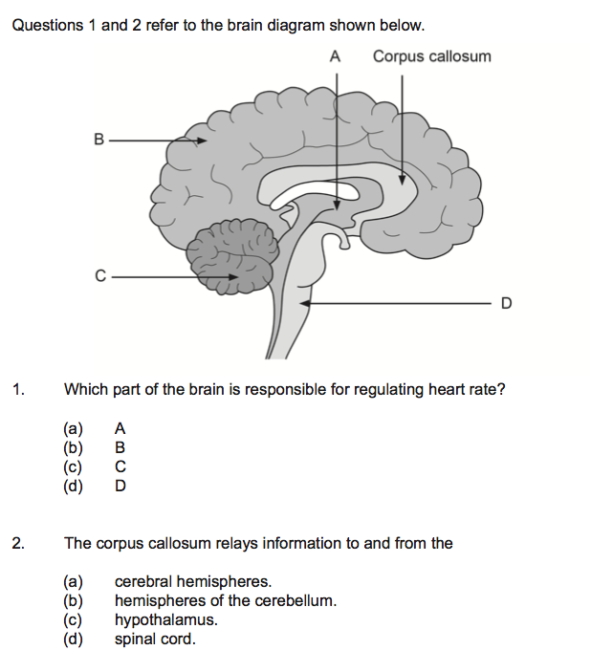
- Refer to the following diagram to answer the following questions.

- Describe the structure of the corpus callosum and state its function. (2 marks)
Structure = white/myelinated nerve fibres (1)
Function = allows communication between left and right hemispheres of cerebrum (1)

- Name the area of the brainstem labelled “D”. State two functions of D. (3 marks)
Medulla oblongata (1)
Controls respiration/breathing; heart rate; blood pressure; sneezing and coughing 1 mark each for 2 (2)

- Name the structure that would be found at “A”. (1 mark)

Thalamus (1)

- Use an arrow to indicate where the frontal lobe exists. (1 mark)
SEE Picture

- State two functions of the frontal lobe of the brain. (2 marks)

Memory formation/motor coordination/thought processes/problem solving/speech/language/social behaviour/personality
Any 2 for 1 mark each

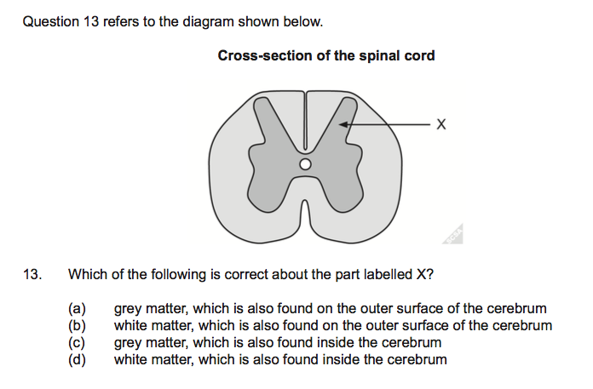
- The diagram above shows a section of spinal cord.
- Identify the structural material that “X” is pointing to. (1 mark)

Grey matter
- Name the main part of the brain where “X” would be found. (1 mark)
On the outside/cerebral cortex
- State two functions of the spinal cord. (2 marks)
Relay impulses/messages to and from the brain (1)
Spinal reflexes (1)

The ‘flight or fight’ response happens when people are confronted with something that could potentially be dangerous.

  - Give one real-life example of a situation where the flight or fight response would occur. (1 mark)

Any realistic situation such as a person sitting an exam/being scared by a snake

  - Name one neurotransmitter responsible for this response. (1 mark)

Noradrenaline (technically adrenaline is a hormone NOT a neurotransmitter)

  - Provide two examples of changes to the way the human body functions as a response to fight or flight. (2 marks)

heart rate increases/breathing rate increases/pupils dilate/bladder relaxes/blood diverted from digestive system Any 2 correct for one mark each

- a) If the occipital lobe of the brain was damaged, explain the possible effects a person may experience. (2 marks)
Seeing “stars”/blindness/vision loss/hallucinations/illusions/inability to see colours (Any 2 correct for 1 mark each)

b) If Wernicke’s area is damaged, explain the possible effects a person may experience.
(2 marks)
Wernicke’s aphasia = poor auditory processing/inability to comprehend spoken language/inability to comprehend written language (Any 2 correct for 1 mark each)

- Using your knowledge and understanding of genetics, describe three examples of the effects of genetic factors on behaviour. (3 marks)

Genetics determines personality (1)
Risk of addictive behaviour linked to genetics/inheritance (1)
Risk of developing mental illness linked to genetics (1)

- Complete this table on psychoactive drugs: (9 marks)
1 Mark for each correct answer
Class of drug | One (1) physiological effect | One (1) psychological effect | Example of a drug in this class
Depressant | Slow body functions such as  Slow heart rate, slow breathing rate , decreased reflexes | Euphoria, reduced perception of pain | Alcohol/  heroin
Stimulant | Suppression of appetite, headaches, dizziness, vomiting | Euphoria, elevate mood, increased mental alertness, increased arousal | Caffeine/  nicotine/  amphetamines
Hallucinogen | Increased heart rate and blood pressure, lack of muscle coordination, convulsions, heart and lung failure | Senses of time, direction and distance are distorted, erratic and violent behavior, paranoia | PCP/ LSD/ Magic Mushrooms

END OF TEST

